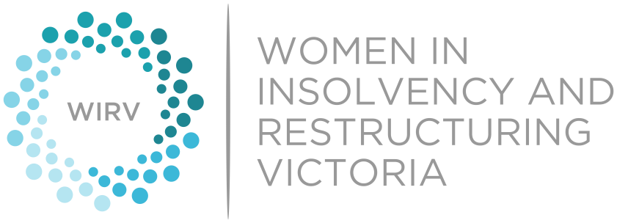 2022 WIRV Awards
Male Contributor to Change
Nomination Form

This award recognises a male contributor to change in the insolvency and restructuring industry who has used his position to support gender equality and promote the advancement of women within their business, the insolvency and restructuring industry and within the wider community.
ELIGIBILITY
This category is open to males of all levels of experience practising primarily in Victoria in all areas of insolvency and restructuring.
INSTRUCTIONS
- Nominees can either be self-nominated or nominated by another person.
- Fill out this form electronically. Feel free to nominate multiple organisations.
- If you would like to nominate a male contributor and think that the nominee would be best placed to complete the nomination form, please email the nominee’s name and best email address to us here awards@wirv.com.au. WIRV Advocacy will then forward the nominee the relevant nomination form to complete. Please advise if you would like to remain anonymous.
- The award will be presented to a male contributor to change in the insolvency and restructuring industry. The award is open for nominations across all areas of insolvency and restructuring.
- Nominees must be primarily based in Victoria.
- Nominees must be a member of WIRV. WIRV Advocacy will liaise with the nominee regarding their membership status, if required.
- Please limit your answer to each question to 400 words or less.
- The nomination form contains the criteria that will be considered in determining the winner of the award. No external or supporting material should be provided and will be disregarded if submitted.
- Keep in mind that the nomination is only as good as the information you provide to us.
- If there is a question on the nomination form that does not apply to the nominee or the answer is unknown, leave the question blank or respond with as much information as is currently known.
- Submit your completed nomination via email to: awards@wirv.com.au

Please submit the completed Nomination Form to awards@wirv.com.au by the deadline on 12 July 2022.
Nominee Information
Name
Organisation
Address
Telephone (business) and E-Mail
WIRV Member | Yes / No / Unsure
Please answer each of the below questions and provide relevant examples.
- How has the nominee used his position to support gender equality and the advancement of women in the insolvency and restructuring industry, and why does the nominee deserve this award?

- How is the nominee a role model within their organisation and/or in the industry more generally when it comes to promoting gender equality and the advancement of women?
- Has the nominee been involved in initiatives or policies that have improved opportunities for women in the industry and/or positively contributed towards the advancement of women? Please describe those initiatives and/or policies, the nominee’s role and the impact they had.

- Are there any other noteworthy accomplishments of the nominee that you would like the selection panel to consider?

Nominator Information (if applicable)
Name
Organisation
Address
Telephone (business) and E-Mail

