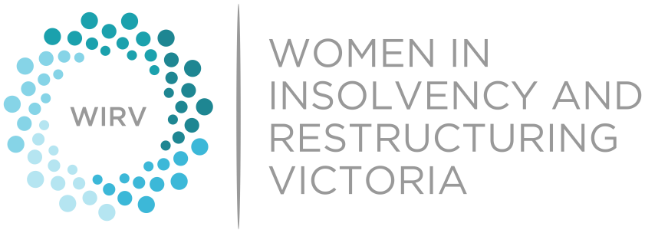 2026 WIRV Awards
Outstanding Practitioner
Nomination Form

This award recognises an outstanding role model who has made a significant contribution to the insolvency and restructuring industry, including by promoting the advancement of women.

ELIGIBILITY
This category is open to practitioners of all genders with over 12 years’ experience across all areas of insolvency and restructuring who are primarily based in Victoria.

INSTRUCTIONS
- Nominees can either be self-nominated or nominated by another person.
- Fill out this form electronically. Feel free to nominate multiple organisations.
- If you would like to nominate an outstanding practitioner and think that the nominee would be best placed to complete the nomination form, please email the nominee’s name and best email address to us here awards@wirv.com.au. WIRV Advocacy will then forward the nominee the relevant nomination form to complete. Please advise if you would like to remain anonymous.
- The award will be presented to the most outstanding practitioner who practises in the insolvency industry. The award is open for nominations across all areas of insolvency and restructuring. Nominees must be primarily based in Victoria and must have practised in the insolvency industry for more than 12 years.
- Nominees must be primarily based in Victoria.
- Nominees must be a WIRV member. WIRV Advocacy will liaise with the nominee regarding their membership status, if required.
- Please limit your answer to each question to 400 words or less.
- The nomination form contains the criteria that will be considered in determining the winner of the award. No external or supporting material should be provided and will be disregarded if submitted.
- Keep in mind that the nomination is only as good as the information you provide to us.
- If there is a question on the nomination form that does not apply to the nominee or the answer is unknown, leave the question blank or respond with as much information as is currently known.
- Submit your completed nomination via email to: awards@wirv.com.au
Please submit the completed Nomination Form to awards@wirv.com.au by the deadline on 16 July 2026.

Nominee Information
Name
Organisation
Address
Telephone (business) and E-Mail
WIRV Member | Yes / No / Unsure
Please answer each of the below questions and provide relevant examples.
- How has the nominee contributed as a practitioner to the industry making the nominee deserving of this award?

- How is the nominee a role model for others and the industry more generally?

- Has the nominee been involved in initiatives or policies that have improved opportunities for women in the industry and/or positively contributed towards the advancement of women? Please describe those initiatives and/or policies, the nominee’s role and the impact they had.

- Are there any other noteworthy accomplishments and outstanding achievements of the nominee that you would like the selection panel to consider?
Nominator Information
Name
Organisation
Address
Telephone (business) and E-Mail

